CALENDAR

A Mini Project in C

Academic Year: 2021-22 EVEN SEMESTER

**Semester** : 2

**Course Code** : 18CSS101J

**Course Titl**e : Programming for Problem Solving

***Submitted by***

*ISHIKA JAIN (RA2111003011813)*

***DEPT****: CSE CORE*

*ISHITA BHATNAGAR (RA2111029010060)*

***DEPT****: CSE CN*

*BHAVYA RAJPAL(RA2111030010275)*

***DEPT****:CSE CS*

DEPARTMENT OF COMPUTING COLLEGE OF ENGINEERING AND TECHNOLOGY SRM INSTITUTE OF SCIENCE AND TECHNOLOGY, KATTANKULATHUR-603 203

**AIM**

To create a Calendar which allows user to view calendar in a neat and convenient manner.

**ABSTRACT**

This project is a simple project built in C language. This project has following features –

1. It displays a nicely formatted calendar of every day of every month.
2. The calendar application presented here is a very simple console application developed using C programming language.
3. It is compiled in Eclipse using eclipse java compiler.

**ALGORITHM**

**Step 1:** Start.

**Step 2:** Declare int variable- get_1st_weekDay, year, day.

**Step 3:** Statement: day=Remainder of {[(year-1) × 365] + [(year-1)/4]– [{year-1)/100] + [(year/400)+1]} divided by 7.

**Step 4:** Declare int variables- year, month, day, daysInMonth, weekday, startingDay.

**Step 5:** Print “Enter your desired year:” in next line. **Step 6:** Read the Year.

**Step 7:** To print months, we use pointer array.

**Step 8:** Declare array- monthDay.

**Step 9:** Using if condition to define the monthDay for month 1.

**Step 10:** Statement: startingDay=get_1st_weekDay(year).

**Step 11:** Initialising a “for” loop with regard to the month. **Step 12:** Print the name of the month.

**Step 13:** Print the name of the days.

**Step 14:** Initialising another “for” loop with regard to the week.

**Step 15:** Initialising another “for” loop with regard to the day.

**Step 16:** Print the day.

**Step 17:** Using if condition to set the format of the calender by aligning the dates and days in the proper order.

**Step 18:** Statement: startingDay=weekday.

# SOURCE CODE

#include<stdio.h> #include<stdlib.h>

int get_1st_weekDay(int year){ int day;

day=(((year-1)*365)+((year-1)/4)-((year-1)/100)+((year)/400)+1)%7;

return day;

} int main()

{

int year, month, day, daysInMonth, weekDay, startingDay; printf("\nEnter your desired year: ");

scanf("%d",&year);

char

*months[]={"January","February","March","April","May","June","July","August","S eptemeber","October","November","December"}; int monthDay[]={31,28,31,30,31,30,31,31,30,31,30,31};

if((year%4==0&&year%100!=0)||year%400==0) monthDay[1]=29;

startingDay=get_1st_weekDay(year); for(month=0;month<12;month++){

daysInMonth=monthDay[month];

printf("\n\n-------------------%s ",months[month]);

printf("\n Sun Mon Tue Wed Thurs Fri Sat\n");

for(weekDay=0;weekDay<startingDay;weekDay++) printf(" ");

for(day=1;day<=daysInMonth;day++){ printf("%5d",day);

if(++weekDay>6){

printf("\n"); weekDay=0;

}

startingDay=weekDay;

}

}

}

# FLOWCHART

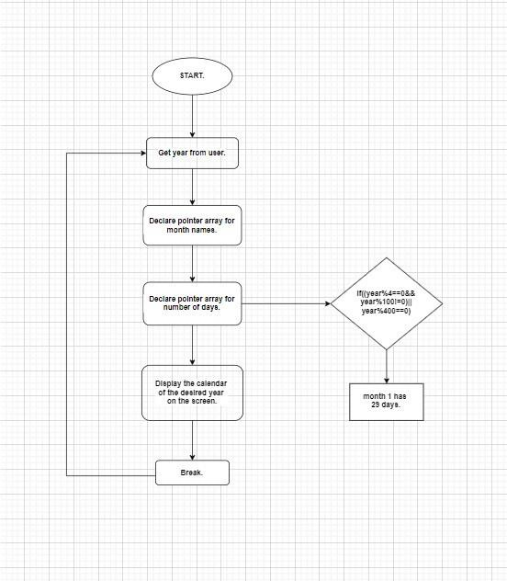

**OUTPUT**

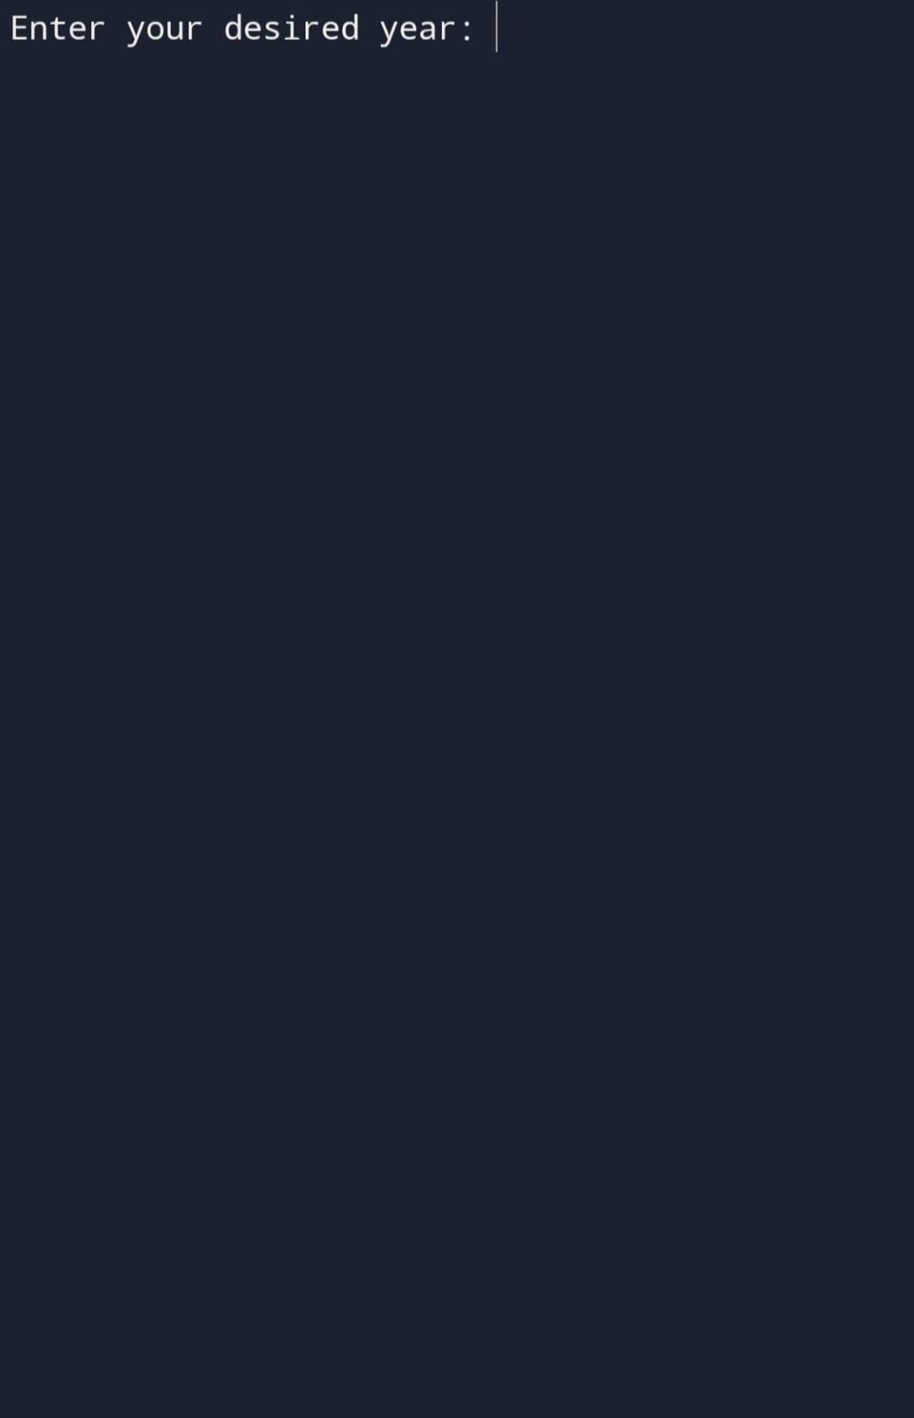

Enter you desi+ ed yes 2022

- - - J onu.a i -y- - - - - - - - - - - - - - - - - - -



## 2 3 5



40

11

1 2

6 / 8

11

13



18

19

20



22

23

24

25

26



29

30



———Febuury



Sun Mon Tue be c! Thri i s F i- Sn t

## 2 5

8 9



1".

15

16



1 0



20

21

22

23



25

26



28



|  |  |  |  |  |  |  |
| --- | --- | --- | --- | --- | --- | --- |
|  | | | 2 | 3 |  |  |
| 6 |  | 8 | 9 | 1 0 |  |
|  |  | 15 | 16 |  | 18 |
| 20 | 21 | 22 | 23 | 24 | 25 | 26 |
| 27 | 28 | 29 | 30 |  |  |  |





1 2

3 4 6 8 9



14



18



20

21



23

|0

11



16

24

25



28

29

30



|  |  |  |  |  |  |  |  |  |
| --- | --- | --- | --- | --- | --- | --- | --- | --- |
| Suta | hon | Tue | We O | Th o i | s | h r | i | So I |
| 1 | 2 |  |  | 5 |  |  |  |  |
| 8 | 9 | 10 | 1 1 | 12 |  |  |  | 14 |
| 1o’ | 16 | 17 |  | 19 |  | 20 |  |  |



24

25

26



28

29

30

31



Sun hon Tue We cl Thu n s L i i So I

2 3 4

6 7 8 9



14



16



18



1 0

11

1J

20



22



24

25



27



29

30



Sun Mon Tue Wee! Thu F s F r i S.I I

1 2

3 6 8 9

|0

11

1 2



14



16



18

10

20



22

23

24

25

26

27

28

29

30



|  |  |  |  |  |  |  |
| --- | --- | --- | --- | --- | --- | --- |
|  | 1 |  | 3 |  | 5 | 6 |
| 8 |  | 1 0 | 11 |  | 13 |
| 15 |  |  | 18 |  | 20 |
| 22 | 23 |  | 25 | 26 | 27 |
| 28 | 29 | 30 |  |  |  |  |

———Se tenet el-



Sure hon Tue Well Thu I s L i i So I

3



5 8

1 l

12



15



17



10



19

20



22

23



25



17

28

29

30

— — — 0 c t old e i — — — — — — — — — — — — — — — — — — — —

Sun Mon Tue Decl Tlnui s F i Sa I



2 3 4 5

9



11

12

16 )0



9

23 24 26

2S

6 8

3 15



20 21 22

27 28

29

30

31

---November



|  |  |  |  |  |  |  |  |
| --- | --- | --- | --- | --- | --- | --- | --- |
| Sun | Mon | Tue | Decl | Tlnui | s | F r | Sa t |
|  |  |  | 2 | 3 |  |  | 5 |

6 9 0

13



16

17



1 9



1 2

20 21 22 23

27 28 30



26

25

— — — Dec e+b e c



3

4 5 8 1 0



12

13

14

15



18



20

21

22

23

24

25 27 28 29 30



26

# RESULT

Our project calendar provides an easy access to a formatted calendar of any desired year in a neat and efficient manner.

Our project has succeeded in managing the data and providing the best output.

**CONCLUSION**

C is most useful for embedded systems, or applications that require the ability to be light-weight and have precise control over system resources. C is lacking a lot of the functionality that more contemporary languages feature, but remains a core tool for Unix developers.

The two developers have tried their best to create a simple and optimised program that works as a calendar, with a user-friendly terminal for the executable file of the source code.